Lauren Crisci

Aiya Sakr

English 407

13 December 2022

Poetry Portfolio

***Paddle Wheel Car***

The gushing sound of a river has been replaced

With the soul crushing sound of my wheel on pavement.

My god what happened to me?

I was not made for this.

Or perhaps I was, which may be more cruel.

My wheel must turn in the waves of the water

Not the grooves of the pavement.

Who made me like this?

My wheel must be damaged.

The hot surface must have torn me to shreds.

Or maybe I was strong enough to face it.

Let me check.

One look down and my heart stops.

A wheel, beautiful and complete in its creation.

Encompassed in rubber with slits.

I was made for this.

***Spilled***

Honey. Honey. Honey.

I know he has the honey.

Hidden in his voice I hear it.

I’ve seen the honey.

Drip

Drip

Dripping away.

Years go by and I’ve noticed the honey dripped away.

Why has the honey gone?

The weight of which fell on to me

Like the honey covering the cold tile.

Stuck stepping in honey that wasn’t for me anymore.

What remains are bruises and scars.

The things that honey would have cured.

What remains is my broken mind.

Destroyed and left to pass the time.

Why’d you have to spill the honey, honey?

***Enchanted***

I blame you for casting a spell

A wicked way to twist my mind

Left me at a point of no return

Questions too hard to ask

An answer you easily deprive me of.

Drop the joint.

Drop the lighter.

Let me beg for an answer.

//

What were you thinking when I was embraced in your arms as you left

soft kisses on my forehead on my way out your door?

What were you thinking as you gently tucked my hair behind my ear

while eyes gazed deeply and smiles grew?

What were you thinking as the sun began to rise and our words stopped slurring,

as we strung my guitar and everything seemed fitting?

What were you thinking as you captured my hand

and skipped in song with joy in our lungs?

Because the moments that I wondered what was going on in your mind,

You were the only thing in mine.

***Virtual Therapy Appointment***

I’m okay thank you though.

He didn’t ask me but I didn’t know what to do. I don’t feel like the earth is going to shatter or like something was taken from my body or soul. Should I feel bad? That smells good. Can I have a bite? I’m sorry. I only want him because he doesn’t want me anymore. It must be because of my dad. I should resent him. God I wish that time would slow down. The earth is spinning faster. Maybe I should get a cat. What does resentment feel like? I need to wash my hair. I don’t feel clean. Just one more episode. I cannot move. Two more episodes. I should have asked his political opinions. Should I feel bad? I can just avoid him as best as possible. Hello!

 I’m sorry I’m just not looking for anything right now!

***Stifle***

One.

Two.

One.

Two.

One.

FREEZE!

Blink.

Eyes open.

“CLOSE THEM.”

He whispers,

Have you ever seen something so beautiful?

Click. Click. Click.

Five things you can see.

Check the walls

The walls.

Why is it so bright in here?

One thing you can taste.

Green eyes, green eyes, green eyes.

Touch, I need to touch something, someone.

Lock the door. Lock it.

Keep it inside.

One.

Two.

One.

***ramifications of a double life***

Imagine, a gate; literal, metaphorical, tangible to the eye and the soul

A blockage, interference, set back.

Can you feel it?

Not between the screen and the viewer

It lies between the viewer and his morality

I see it.

It makes him uncomfortable. Sleepless. Rotting from the inside out.

Keep the gate closed.

He knows where the key lies. The code. The answer to all of his prayers.

Dwindle, hang, forget, lose.

Imagine a world where your actions do not result in consequences.

For context: I am also in Kate O’Donoghue’s Poetry and Visual art class this semester (love her), and we looked at Alyssa Moore’s screenshot poem(s). I absolutely loved this idea and was inspired and tried it out for myself!

***Up in the air***

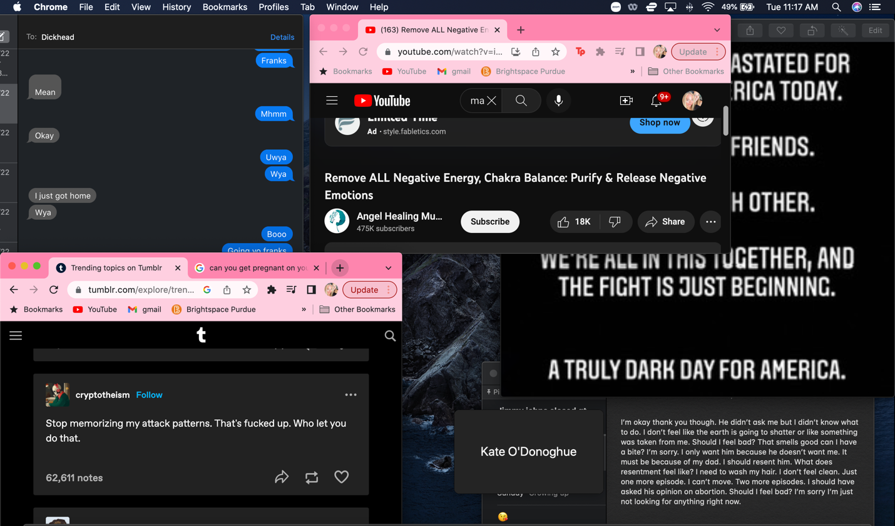

Personal Statement

Throughout this semester, I noticed a prominent change in my creativity. I attribute this most to seeing the work of my peers and becoming inspired by the creativity of others. I think at the beginning of the semester I was quite stuck creatively, limiting myself to certain mediums or formats of poetry because I thought I couldn’t break out of the box. Poems like Nate’s Spotify playlist were outlets and exposure for me to ideas that I would not have organically thought of. After these sixteen weeks, I feel more confident in my creative writing having been consistently thinking of ideas for my poetry and other creative outlets. I wish I had more poems to include in this portfolio, but I found myself focusing more on creating short stories recently and sort of ran with that. I put an emphasis on expanding my vocabulary, as I feel that is something that I can always improve. I often look at the work of other poets and feel like my language is inadequate in comparison. I think this fosters insecurity in my work that I feel is visible to an outside reader. As the semester progressed, I was able to gradually let that insecurity go and become more free with my writing. This was honestly a personal goal of mine and I am really happy that I achieved that.

I think on a larger scale, this class changed my perspective on the crafting of poetry, how it works and how it can change. I found myself becoming inspired by the things around me, and even attempting to write from a perspective that is not my own. I found this process quite liberating and as a true expansion of my mind. Particularly in trying to write from a different perspective, I realized that creating experiences that aren’t my own is extremely difficult. There are emotions that I have never personally felt, and can only use my imagination to describe. My poem titled “ramifications of a double life” was inspired by the book My Policeman, specifically the character Tom. Tom is a gay man living in the 1950’s in Brighton, England who marries a woman while being in love with a man. This is a life that I have not lived, so I took a deeper look at Tom’s character, the way he talks, how he reacts to situations, what is his true character and how does he show it. These steps of the craft are often forgotten or looked over because the reader, and the poet, can not put into words how the creative process is vast and intimate. Processes like this were the core of my exploration of poetry in this class and not only changed my own opinion on the craft of poetry, but also I believe greatly attributed to improving my writing.

I greatly appreciated the work of my peers this semester and wish I could thank all of them for being vulnerable and sharing their work. The work of others has great power for a writer and I really came to acknowledge that this semester. I am looking forward to going further in my poetic writing and taking the skills I learned in this class to use in future courses and my future career.